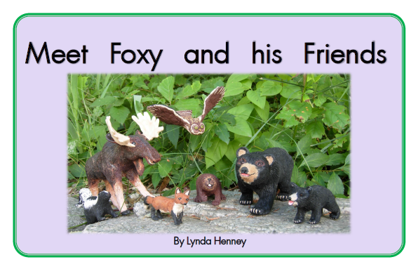

Inspiring, engaging, and fun!
Little books for guided reading, reading intervention, classroom libraries, independent reading, or home reading.

Second Slider image:
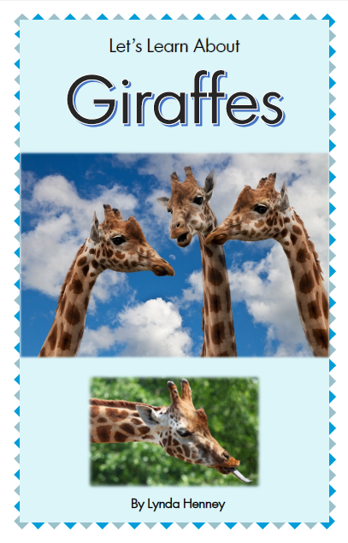
Non-fiction books to intrigue even your most reluctant readers!
Many children prefer non-fiction books. These non-fiction books are written at very low reading levels (less than level 10), which makes them accessible to all readers, regardless of grade level.

